Daily tasks to keep cleanings on track:

* Respond to NEW BOOKING task by:
  + Scheduling cleaning or ensure cleaning is scheduled
* Respond to CHECK IN TOMORROW task by:
  + Double check cleaning is complete or scheduled
  + Send necessary messages to prep next day cleaners (heads up about special needs, same day turnarounds, etc)
  + ***Watch out: Same Day Last minute bookings will also say “CHECK IN TOMORROW”
* Respond to ALTERATION task by:
  + Send text message to W&G (they are not notified of alterations)
  + Adjust manual cleanings
* Ensure QT’s are on track and guests are prepared for
* Be available to respond to cleaners
* Order restock

Hospitable Notifications:

Cleaners

* Text: NEW BOOKING
  + Immediately after a new reservation is confirmed
* Text: CANCELLATION
  + Immediately after a new booking is canceled
* Text: ALTERATION
  + Immediately after a booking alteration
* Text: CHECK IN TOMORROW:
  + 10:00 am day prior to check in
  + ***Watch out: Same Day Last minute bookings will also say “CHECK IN TOMORROW”

Owners

* Email: NEW BOOKING
  + Immediately after a new reservation is confirmed
  + *Includes gross booking $ amount
* Email: CANCELLATION
  + Immediately after a new booking is canceled

Hospitable Pro tips:

* Instead of marking messages as unread, filter by “Awaiting Reply”
* If you see my ambassador messages pop up, you can filter them out by clicking on “All Properties”
* Important for guests who we are worried about leaving us a bad review OR if the first night is rough: Turn off auto messages by clicking on “Edit” beneath “Activity” on the Left sidebar of a messaging thread
* Heads up: This message will be automatically sent when you “Pre Approve” a stay: *“I went ahead and pre-approved your stay! You have 24 hours to confirm before the approval expires. If you have any questions or need anything else, feel free to reach out. We'd love to host you!”*
* Go here to see pending messages to be sent: [*https://my.hospitable.com/gx/overview*](https://my.hospitable.com/gx/overview)
* Check out Knowledge hub! We need to add the PDFs for each property but once we do this is valuable.*:* [*https://my.hospitable.com/properties/property/1542440/knowledge*](https://my.hospitable.com/properties/property/1542440/knowledge)
* Kylie: Are you getting the notifications about battery being low? You can view Smartlocks by clicking on “Devices”: https://my.hospitable.com/devices
* Oooo check out pending reviews: <https://my.hospitable.com/gx/overview> Very cool and easy way to personalize reviews a bit more. Let’s use this! Kylie, maybe this can be part of your review process on Tuesdays? (Otherwise, a 5 star auto review will be left 3 days after check out.)
* Kylie: You can start replying to reviews from hospitable! AI responses to help too! <https://my.hospitable.com/gx/overview>
* Check out tasks: <https://my.hospitable.com/operations/task-rules> I wonder if we can use this to help automate tasks that we do? I think it makes the most sense to let this replace Breezeway…. Need to game plan for coming off Breezeway (except for W&G of course)
* To create owner stay: Click “New Booking”. Change cost to $0. Enter “Owner Stay” in first and last name. Enter email address for our primary contact.
* Direct booking fyi: Guests are going to be prompted to upload ID. Can advise guests that easiest process is to do it on the phone

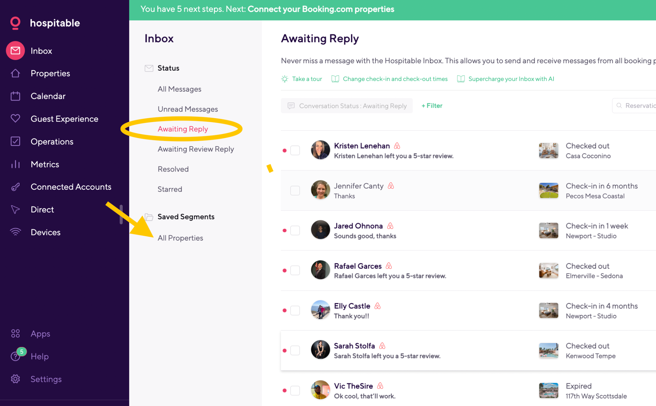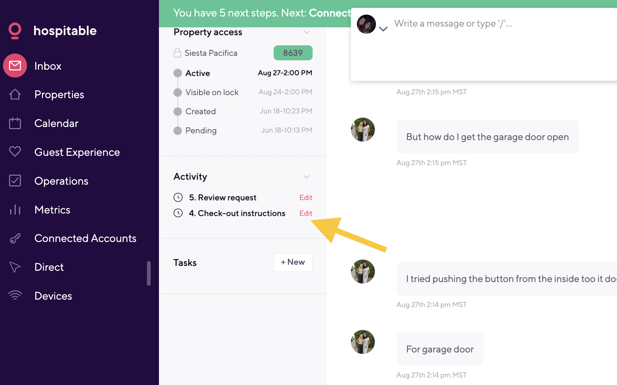

Guest Messaging Guide

|  |  |  |  |  |
| --- | --- | --- | --- | --- |
|  | Default | Paradise Ln | The M | Exception |
| Can we drop off luggage early? | Thanks for reaching out! We're unable to accommodate early luggage drop-offs due to limited storage space and the need for our cleaning team to have uninterrupted access to prepare the home for your stay. We appreciate your understanding. If you'd like, we're happy to provide recommendations for nearby places to visit while you wait. | Thank you for reaching out! We're happy to accommodate early luggage drop-offs to our garage after 11:30 am. It's crucial that no luggage is dropped off prior to this time, and we kindly request that guests only access the garage prior to time of check in.  You can access the garage using the touchpad on the left side of the garage. The code is 7117 Enter (press keys slowly).  If you have any questions or need further assistance, feel free to let us know. | Thank you for reaching out! We're happy to accommodate early luggage drop-offs to our garage after 11:30 am. It's crucial that no luggage is dropped off prior to this time, and we kindly request that guests only access the garage prior to time of check in.  You can access the garage using the MyQ app. What is your email address? We can add you to the app now.  If you have any questions or need further assistance, feel free to let us know. | *We can check with the cleaner to see if early luggage drop-off is possible, provided that:*   1. *It doesn't disrupt the cleaning schedule.* 2. *The cleaning team is present when the guest drops off luggage.* 3. *There's no risk of overlap between the departing and arriving guests.* 4. *The guest doesn't enter the property before it's cleaned to avoid any negative first impressions* |

|  |  |  |  |
| --- | --- | --- | --- |
|  | Share backup code | Troubleshoot | Share lockbox info to access spare key |
| The Schlage or Kwikset door code is not working. *Common issues:*   1. *Guests mistakenly go to the wrong door (frequent at Arcadia, Heatherbrae 1, Heatherbrae 23.)* 2. *The guest is trying to use the code for a nearby lockbox instead of the Smartlock. (common at Heatherbrae 1 because there is a screen door that guests need to open to access the Smart lock on the main door)* 3. *The Schlage lock loses connection, causing the shared code to not sync with the lock.* 4. *The Schlage lock battery is depleted.* 5. *The guest is checking in >2 hours prior to check in and their unique code is not working.*   *Check lock status in Guesty Locks Manager:*  [*https://app.guesty.com/integrations/guesty-locks-manager/locks/linked*](https://app.guesty.com/integrations/guesty-locks-manager/locks/linked) | Hi [GUEST NAME], can you try code [XXXX]? Let me know if that works for you.  *Follow up after guest confirms new code is working:*  Great, thank you for confirming. Apologies for the inconvenience. We use Smartlocks, and a unique code is generated for each guest. However, it seems that the code didn't sync properly this time. You can continue to use the code [XXXX] for entry.  *\*Avoid sharing cleaning code. Instead, share a backup code from “Locks Manager” in Guesty. However, if nothing else is working, you can share cleaning code as a last resort.* | Hmm. That code should be working for you. Let’s make sure you are at the right unit.  Arcadia:  Our unit is right on 38th St. You should be able to see the road from the front door. If you entered through a gate into a courtyard, then you are in the wrong place.  Heatherbrae 1:  There are 2 courtyards that look almost identical. Can you make sure you are at 7200 E Heatherbrae and not 7400 Heatherbrae?  OR  Can you confirm that you are using the touchpad on the door and not the lockbox? You will need to open the screen door to access the touchpad.  Heatherbrae 23:  There are 2 courtyards that look almost identical. Can you make sure you are at 7400 E Heatherbrae and not 7200 Heatherbrae? | Okay, we can try one more thing. We have a spare key available in a lock box which you can find [see property notes for lockbox location]. Use code [XXXX] to open the lockbox. |

|  |  |
| --- | --- |
| The guest is unable to open the lockbox. | Hi [GUEST NAME], can you try holding the lockbox shut tightly and then enter the code? Our cleaning team just used the lockbox so we know it worked recently. Occasionally, the lockbox can get jammed. You might also try gently shaking the lockbox to ensure the key inside isn't causing any obstruction |

|  |  |
| --- | --- |
| Can I check in early / check out late? **(When we do NOT have a guest checking in or out on the same day)**   * *If we are unlikely to get a last minute booking, we can offer up to a 2 hour complimentary early/late check in/out.* * *If the guest wants to check in/out more than 2 hours of the scheduled check time, we need to charge an hourly rate.* * *ONLY OFFER EARLY CHECK IN IF WE”RE UNLIKELY TO GET ANOTHER BOOKING.* * ***Extended Early Check-In****: Need more time? If available, we offer check-in earlier than 1:00/2:00 PM for $20/hour ($40/hour for Desert Rose). Let us know your desired time, and we’ll confirm and apply the charge.*   **DON’T FORGET:**  **If a guest decides to pay to check in early/late:**   * Request the fee from the guest through Airbnb (this is a little doorcomplicated for VRBO, direct booking, tag me in if it’s not an Airbnb booking) * Block the night before or after in the calendar so that we don’t get another booking * If guest will be checking in more than 6 hours early or checking out more than 4 hours late: Add new Schlage code   **VERY IMPORTANT:**   * Schlage Smart locks do not generate the code until 2 hours prior to check in. If guests are paying to check in earlier than 2 hours before check in, we MUST SHARE A BACKUP CODE with the guest so that they have access. * Backup codes can be found in Guesty locks manager: <https://app.guesty.com/integrations/guesty-locks-manager/locks/linked> | If we are likely to receive another booking (it’s far out, busy season, or a weekend):  If we don’t have guests checking out on the same day, we’re happy to offer a 2 hour early check in. However, we won’t be able to confirm until the day before your stay.  If we are unlikely to receive a last minute booking (last minute, off season, weekday):  We’re happy to offer a complimentary [up to 2 hours before/after check-in/out] [CHECK-IN / CHECK-OUT]. If you need more time beyond that, we can usually accommodate for $20 per additional hour. Just let us know what time you’d like to [CHECK-IN / CHECK-OUT], and we’ll do our best to make it work!  Example of how to offer option to pay for early check in:   * Hi Cindy, we can’t confirm an early check-in until the day before your arrival, as we may need to accommodate a last-minute booking. However, we’re happy to offer a complimentary 2 p.m. check-in as long as there isn’t another guest checking out that morning. If you’d like to check in earlier than 2 p.m., we can often accommodate for $20 per hour beyond the complimentary two hours, depending on availability. Let us know what time you’d like to check in, and we’ll do our best to make it work! |
| Responding to request for early cancellation of a long stay **When we decide to make an exception to our cancellation policy**   * 1. If appropriate, briefly empathize with guest * 2. Don’t make any promises. * Let the guest know:   + Our cancellation policy is in place to protect our team and business. Often we’re not able to make exceptions.   + We also understand the unpredictable nature of this and want to be understanding. * 3. If the guest has not yet initiated the change of dates or cancellation on their end, ask that they do. This is required before we can move forward   + If we're able to get another booking, then we can be more flexible with the reimbursement. | **Example of email to guest:**  [Judy called me yesterday to let me know they won't be able to return to the cabin. We're so sorry to hear that. Are you able to change the end date on your end?] I've started a conversation with the owner about the possibility of providing reimbursement for the unused nights. This is always a tight spot for us, but we understand the unpredictable nature of these situations and want to be understanding.  The first step is to adjust the calendar so we can reopen these nights for booking. If we're able to get another booking, then we can be more flexible with the reimbursement.  **Follow up to guest to say we cannot approve:**  I hope you're doing well. I wanted to follow up on your refund request. Unfortunately, the owner cannot approve the refund, and there's little we can do to change this decision.  We understand how disappointing this must be, especially given the circumstances. In an effort to support you, the owner is offering a transferable $850 credit that can be used for a stay at the cabin anytime within the next 12 months by your or a family member or friend.  We genuinely empathize with your situation, but our cancellation policies are essential for maintaining our operations. We hope this credit provides some flexibility and helps you plan a future visit.  Thank you for your understanding. Please let us know if you have any questions or need further assistance.  **To owner (via email or if short, text/Whatsapp):**  [Context. For example: Our long stay guest at the cabin has been enjoying a wonderful time. Then the guest Judy messaged me to say her husband, Don, has Pneumonia and is in the hospital and they won't be able to return to the cabin. They're an 83 year old couple who was staying to spend time with their daughter.]  Our policy is no refunds 30 days after check in. So we are not responsible for reimbursing any amount.  Also, we will be able to unblock the calendar and earn income for unused nights.  Judy called me yesterday and mentioned that any amount would help.  She acknowledged our cancellation policy and expressed gratitude for any assistance.  **Would you feel comfortable reimbursing 20% 0r 25% of the unused nights? That would be a $832 or $1040 reimbursement.**  I feel confident we can get $2000 in bookings over that time anyway so we'll actually come out ahead. I also already backed out the cleaning fee and fees. Math is below.  I'm open to another arrangement if this doesn't feel good for you.  Thank you! Brindy  **$8185 Total stay amount**  - $319 transaction fees  - $150 cleaning fee  = $7716  /48 nights booked  = $160 x26 unused nights x $160  = $4160 x 20%  = $1040 |

### Are pets allowed?

* If guests includes their pet when making the reservation AND it’s a pet friendly property, the pet fee will be requested and charged automatically
* You can confirm if a dog is included in the reservation in Guesty
* Pet fee covers up to 2x dogs. (Can consider a 3rd dog on a case by case basis but need to require additional fee)
* For properties where we only allow dogs on a case by case basis: Consider guest reviews, length of time Airbnb account has been open
* Refer to Property Spreadsheet for pet fees, and pet policies:<https://docs.google.com/spreadsheets/d/1vYBsQHgBkKXs2kDteu7Pim5__zXCWQ7ANzdMovoi6kE/edit#gid=1239572775>

**Are cats allowed?**

* Only listings that are dog friendly can be considered for cats
* Before accepting a guest with cats, ask: Have you traveled with your cat before? We typically do not accept cats but are willing to discuss with the owner to see if we can make an exception.
* If the answer raises any red flag at all, can respond with:
  + We spoke with the owner and are not able to accept cats in our home at this time. Best of luck finding something that will work for you!
* If the guest's answer does not raise any red flags, we can respond with:
  + We are happy to accommodate your cat as long as the following conditions are met. We require guests to provide a litter box as well as a cat tree or similar item to prevent any scratching on furniture. Are you able to provide these items? We also require that cats are neutered or spayed. Can you confirm if your cat has been spayed/neutered? Lastly, we do require a non refundable pet fee of ($00.00). Is this agreeable? If so, we can request the additional fee and we’re all set.

**Pet hair from guest but didn’t pay :**

* We hope you made it home and are settled in! Our cleaning team let us know that they found quite a bit of pet hair and charged us extra for cleaning. We do charge a $90 pet fee per our Airbnb listing and house rules. I went ahead and charged this through Airbnb.
* (Attach pictures)
* How to add a pet fee when booked through VRBO. https://help.guesty.com/hc/en-gb/articles/9360495210013-Adding-an-additional-fee-to-a-reservation-manually

**Other pet related fees:**

* $75 charge for pet waste left behind
* $200/$300 fee if guest brings pets without prior approval
* Cat fee is 2x dog fee

**Service dogs? (If not a dog friendly home)**

We do have a strict no pet policy. This is because the owner does not allow pets in the home. However, we do not consider service animals to be pets.

We do not need any paperwork, however we are required to ask what work or task the service animal has been trained to perform?

As long as it is a trained service animal who will not be left unattended or allowed on the furniture, and as long as you agree that you will be responsible to pay an additional cleaning fee for any pet hair or mess left behind, we’re happy to host you.

### Maintenance issue

* If a guest reports a maintenance issue, the first step is to ask a couple questions so that we are clear on the scope of the issue.
* If it’s a thermostat or ac/heat issue, ask for a photo of the thermostat
* Always ask for a photo where possible
* Ask relevant questions like;
  + Was it like this when you arrived?
  + When did you first notice this?
* Determine if it is urgent or if it can wait until after the guest checks out
* If it’s not urgent, and if we’re willing and able to repair prior to check out, be direct in asking the guest: Would you prefer us to send someone to fix this during your stay or wait till after you check out?
* Never over promise. Instead you can say things like:
  + I’m going to see how quick we can have someone out. I will let you know as soon as I confirm.
* For urgent issues, keep the guest updated every few hours. Even if you we don’t have an update, you can say things like:
  + We’re still waiting for our handyman to confirm his schedule. I should know shortly. Thank you so much for your patience.

### Red flags to watch out for / Responding to weird inquiries:

* RED FLAG #1: A brand new Airbnb account < 1 year old
* RED FLAG #2: Identity is not verified
* If we receive a request from a guest with both red flags, we can respond: We require guests to have their identity verified through Airbnb and can only accept stays from guests who have a good track record with Airbnb.
* When we receive strange sounding requests from guests like this, we do not need to respond in a hospitable manner. You can be firm and cold. We don’t want to host them. However, response time still matters for the algorithm. So, quick responses are important.
* If too many red flags, immediately click “Decline” and decline the request
* If they are agreeable to having their identity verified, and if they are sending kind messages that make sense, then it might just be the person’s first time on Airbnb.

### 

### How to pay a requested fee:

You should have an email from Airbnb. This link should also take you there: <https://www.airbnb.com/resolutions>

### 

### Questions about Airbnb payments:

* Airbnb payments: As hosts, we don’t handle any of the payment processing for Airbnb bookings. This is always handled through Airbnb. If guests have questions about changing their credit card, or when their card will be charged, you can let them know
  + “As hosts, we don’t have visibility into payment details. I recommend reaching out to Airbnb Support at 1 (844) 234-2500 and they can help clear this up for you.”

Airbnb won’t accept reservation:

If Airbnb won’t accept a reservation because of too many people in a house around a holiday and assuming they’re having a party, respond with something like the following:

Hi (name)! Sorry you’re having trouble booking. A couple options—

First you can try to have someone else in your party book on Airbnb. The reason that the booking is being flagged is likely because your location (Tucson) is within close proximity of our home. It’s a frustrating thing about Airbnb’s system for flagging potential parties but from experience I know it’s something they won’t budge on.

The second option is you can book with us another way. The tricky thing is that we can’t share this info through Airbnb.

You can try to look it up— it is called SouthwestWanderlust

### Wi-Fi isn’t working:

* Can you try unplugging the Wi-Fi router for 10 seconds then plugging back in? It’s the [white box beneath the TV].
* Also, is the router blinking any lights? Are there any lights on?
* Can you try using Wi-Fi on another device or can try streaming something on the TV?
* (Actions: 1. Log into Cox account to see if any outages, issues 2. Wait 2 hours. 3. Call provider. Sometime they can do a re set on their end that works. 4. Decide if necessary to stop in person to verify not working)

**Identify verification:**

* (For Airbnb guests who send a request and do not have their identity verified)
* We’d love to host you. We do require that guests have their identity verified through Airbnb. You can do this by typing /verify at the end of Airbnb’s web address. Once verified, we can pre approve your stay.

**Request to waive cleaning fee:**

* Our cleaning fee is a pass through fee that goes directly to pay our team. Our cost is the same regardless of length of stay so we don't have any flexibility. We'd love to host you! I'll go ahead and pre approve your stay in case this works for you.

**If a guest asks for the address prior to confirming their booking:**

* Do not share the specific address with guests prior to booking. If they have questions about the location, you can provide the roads of a nearby intersection.

**Request for discount:**

* We can consider offering a 10% discount if the following apply:
  + The request is less than 30 days out
  + The stay is 4+ days
  + The guest has 2+ great reviews and/or you have reason to believe this will be a great guest
  + ***Pay attention for any red flags of the guest being extra needy bc this is a common stereotype for people who ask for discounts***
* If a discount is not available:
  + Thank you for your inquiry! We’d love to host you. We do not have any discounts available at this time. I’ll go ahead and pre approve your stay in case this works for you!
* If discount is available:
  + Apply 10% off the nightly rate only (discounts do not apply to cleaning fees) and send a special offer.
  + DON’T FORGET to add the cleaning fee amount to the nightly rate. The cleaning fee is NOT automatically added.
    - Special offers must be sent through Airbnb. Here’s how: <https://www.airbnb.com/help/article/35#section-heading-1-0>
  + Send message to guest to say this is it’s because of good reviews:
    - Thank you for your interest in our home. We don’t typically offer discounts, but given your excellent track record, we're happy to provide a 10% discount for your stay. We’ll send a special offer now.

**Roku TV remote is lost or not working:**

* (if there’s extra batteries direct them where)
* Thank you for letting us know, there is an app to access the TV. Make sure you are on the Wi-Fi and this is the link. We will be sure to order a new remote asap: <https://apps.apple.com/us/app/the-roku-app-official/id482066631>

**Can I see the apartment / house before booking?**

* For stays < 30 nights: Always no, no exceptions
* The only time we can consider allowing a guest to view the apartment prior to booking is if the stay is > 30 nights AND the guest has their identity verified and an excellent track record (2+ reviews, established Airbnb account)
* It’s risky, logistically difficult, and time consuming to agree to allow guests to see places prior to booking so the only time it should even be considered is if it’s a high value, long term booking.

**Can I Venmo you? // Can I book with you directly?**

* We can only accept bookings through Airbnb. We’d love to host you if this works for you.
* *OR if it is a trusted guest…*
* “We are limited in what we can share here. How can we find you?”
* OR “We are limited in what we can share here. You can find us at Southwest Wanderlust.
* Direct booking site: [www.southwestwanderlust.com](http://www.southwestwanderlust.com)
* (keep in mind, Airbnb will block any messages that appear to be website address or email addresses so guests have to get creative in how they send this. We need to be *very* careful about what we request because Airbnb will flag our account if they think we are encouraging or soliciting bookings outside of Airbnb.

**Double Booking / Host Cancellation**

* Hello, This booking was canceled due to a system error that created a duplicate listing for our home with inaccurate rates and availability. We’re unable to accept bookings through this account and are working with Airbnb’s security team now to resolve this issue. Your reservation has been cancelled and you will receive a full refund. If you’re interested in re booking, you can do so here as long as your dates are available:

**Superhog false request to Airbnb guest:**

* Thank you for checking on this. Yes this is legitimate, however, no action is required. This is only required for stays outside of Airbnb and should not have been sent. I can go ahead and delete the request from my end. No further action is required and we look forward to hosting you!”

**Pet hair from guest but didn’t pay :**

* We hope you made it home and are settled in! Our cleaning team let us know that they found quite a bit of pet hair and charged us extra for cleaning. We do charge a $90 pet fee per our Airbnb listing and house rules. I went ahead and charged this through Airbnb.
* (Attach pictures)
* How to add a pet fee when booked through VRBO. https://help.guesty.com/hc/en-gb/articles/9360495210013-Adding-an-additional-fee-to-a-reservation-manually

**How to handle last minute stays:**

* Identity verification is required, no exceptions
* First response to potential guest: Thank you for your inquiry! Let us double check with our cleaning team that we can be ready in time. What time are you looking to check in?
* Once we accept your stay, your card will be charged and the stay will be confirmed. Can you confirm that you would like to move forward? We do require a quick phone for last minute guests before we share the door code. Can you agree to give us a quick phone call once the stay is confirmed? (if guest has 2+ positive reviews and NO red flags, then a phone call is not required. If there is any question, call them)
* If a phone call is required prior to sharing code for a last minute stay.
  + On the phone: “We always like to speak with last minute guests. Is it okay if I ask a couple quick questions to make sure we’re all set?”
  + “What brings you to …?”
  + “We do not allow more than [x] people in the home at any given time. Do you plan on having anyone over?”
  + “Do you know what time you will be checking in? And what time do you think you’ll be checking out?”
  + “We only have parking for [x] number of cars. Will this work for you?”
* If there is a security concern, you can:
  + Block the auto message in Guesty so that the check in code isn’t shared
  + For Schlage locks, You can replace a guest code is Guesty to quickly block access:<https://app.guesty.com/integrations/guesty-locks-manager/locks/linked>

**Request compensation for damage examples:**

Hi Tianna,

Our cleaning team noticed that a new mattress topper was left badly stained, along with a couple of towels that had been used to clean up a brown liquid. We understand that this may have been an accident or an effort to clean up, and we appreciate the other efforts you made to maintain the space.

While we won't charge for the additional cleaning needed, we do need to request compensation for the stained towels and mattress cover. Thank you for your understanding.

Best regards,

Guests who require special handling:

* **VIP**
  + First 3 guests of a new listing
  + Return guests
  + Guests who are staying >30 nights
* **Last minute guests**
* **Escalated**
  + Guest let us know they are unhappy
* **Bad guest**
  + Guest caused damage to the home

**Request to guest to leave a review:**

*Our auto messages already ask the guest for a 5 star review. However, for early guests at a brand new listing, reviews are super duper important so if the guest doesn’t leave one, on the 3rd day after they check out, we can send this message as long as it was a smooth stay and we already left a review*

"Hi [Guest's Name], We hope you made it back home and are settled in. We're so glad to hear you enjoyed your stay! If you're able, it would mean a lot to us if you could leave us a review. This is a new listing and reviews help us a bunch. We already left you a five-star review and thank you for taking such good care of our home. Of course, if you do have any feedback, please feel welcome sharing that through messaging here. This helps us grow as hosts.

Handwritten Notes

**First 3 guests:**

"Welcome to [City or House Name]! We’re so thrilled to have you as one of our first guests. Your feedback means the world to us as we work to make this home as cozy and comfortable as possible. Our goal is to provide a truly 5-star stay, so if there’s anything we can improve or assist with, please don’t hesitate to reach out to us directly through Airbnb. Thank you for staying with us—we hope you feel right at home and have a wonderful visit!

OR

We’re delighted to welcome you as one of our first guests! Your feedback is so important to us as we work to make our home as cozy and comfortable as possible. Our goal is to provide a 5-star stay so if there’s anything we can improve or assist with, please feel free to message us directly through Airbnb.

Thank you for choosing to stay with us. We hope you have a wonderful visit!

* Host name (ie: Brindy & Michelle)

Escalations

**To send to someone if a cleaning was missed:**

Hey Shannon, it looks like our team finished up cleaning for you. Do you now have everything you need?

Once again, I am so sorry about this. We hold ourselves to a higher standard and we really regret that you had to experience the inconvenience that this caused.

We’ve already taken action to ensure it does not happen again. I will send reimbursement now for last night plus the cleaning fee. You should get an email from Airbnb confirming once this goes through.

Truly, thank you for your kindness and flexibility. I know how frustrated I would have been and we appreciate your understanding. If there’s any more we can do to help make up for it, please let us know.

**To prevent a bad review from someone who a cleaning was missed for (use carefully because if guest is not understanding it can backfire):**

Hi Giselle, I wanted to thank you again for your incredible kindness and understanding about the cleaning issue upon arrival.

Since this stay doesn't deserve a 5-star review, if you'd consider not leaving a review at all, we'd greatly appreciate it.

We immediately focused on creating a foolproof process to ensure this never happens again—we want to learn from this.

Thank you for allowing us to make it right by reimbursing the first night. We will, of course, leave you a glowing review and would be grateful if there isn't a review that reflects this aspect of your experience as our goal is that this never ever happens again 😅

Thank you again, and if you're back in Tempe, let us know! We’d love to welcome you back with a 10% discount 😊

**Example of message to send to guest who left a 3 star review or lower:**

(Break up into 2 messages based on guest response)

Hi Hayley, I hope you’re doing well! I to thank you for your kind words in the public review and for choosing to stay with us. It’s wonderful to hear that you enjoyed your time at the house.

I also noticed your private feedback about the floors and truly appreciate you bringing that to our attention. We didn’t hear from you during your stay, so I wanted to mention that we’re always available to address any concerns in real-time to ensure everything is perfect while you're with us.

I saw that you left a 3-star rating. Since we always strive to offer a 5-star experience for all our guests, I wanted to ask if there’s anything specific we could do better to make the home even more enjoyable.

Airbnb’s rating system can be a bit tricky, as they consider anything less than 5 stars as indicating that the home might not be recommended.

Our top priority is ensuring that our guests have a wonderful experience and truly enjoy their stay. We also want our reviews to reflect the effort we put into making each visit special. With the upcoming Superhost review, it’s important for us to maintain these high standards.

Airbnb doesn’t allow editing reviews after they’re published, but you can request removal if you’re comfortable with it.

If that’s something you’d be open to, here’s the link to request it:

https://www.airbnb.com/help/article/3582#section-heading-2-0

For easy reference, your confirmation code is:

HMD9ARYYFC

Of course, there’s no pressure, and I completely understand if you’d prefer not to. We’re just grateful for your feedback and for choosing to stay with us.

**Example of message to send to guest who left a 3 star review or lower:**

Hi XXXX,

I'm reaching out to see if there's anything you think we could do to improve our home, such that it would earn a 5-star review. Airbnb considers anything under 5 stars unsatisfactory, so although 4 sounds good (and on most scales, it is), we are truly striving for the 4.8 minimum Superhost requirement, especially since the next Superhost assessment is coming up. Considering your review sounds like you had a great experience, I am hoping to get some insight as to how we could meet (and hopefully exceed) what it would take to earn 5 stars in the future.

I truly appreciate any feedback you can provide, thank you so much.

After they respond, I tweak something like this -

Unfortunately there isn't a way to edit a published review, but it can be removed if requested by the author. In case you'd be open to it, you can request it here:

[https://www.airbnb.com/help/contact-us/channel](https://www.airbnb.com/help/contact-us/channel?fbclid=IwZXh0bgNhZW0CMTAAAR2k1VNdiaWLBxilrtj_QbB7NbyywPkYrDkpoOpKZfKgAFQ_bLGDuM-5iVc_aem_QEVmiVPylvCMm3GndHVf9g)

Your confirmation code was: XXXXXXXXX

I understand if not, but if you did enjoy your stay, I would really appreciate the help.

Text message to send to guests who had a positive experience and who we want to encourage to book with us directly:

Hey [GUEST NAME], this is Brindy, your Airbnb host from [NAME OF HOUSE OR CITY]. Thank you again for staying with us! We’d love to host you again. Next time we can save you on Airbnb fees and invite you to book directly at www.southwestwanderlust.com. As an extra thank you, you can use code BESTGUEST for 10% off a 4+ night stay. Feel free to save my number in case you have any questions 😊

Upsell extra days:

**For any stay (send morning prior to day of check out):**

We hope you're enjoying your stay so far! If you're interested in adding an extra day (or more), we're happy to offer a 10% discount on any additional nights. Let us know if you're interested, and we can send you a request to extend your stay. Otherwise, enjoy the rest of your time and let us know if there’s anything we can do to help make your stay more enjoyable.

**For a >30 day stay (send 1 week prior to check out):**

Hi (Guest name)! We hope you're enjoying your stay so far! We wanted to check in and confirm if you are still planning to check-out on (date)? If you're considering extending your stay, our home is available. We're happy to offer a 10% discount on any additional days you might want to add. Let us know if you're interested, and we can send you a request to extend your stay.

**If guest agrees to extend:**

Send a request through Airbnb to “Change reservation”. Change the dates. Then change the price and include a 10% discount on additional nights.

Daily Security Check

Loom video:

<https://www.loom.com/share/4c1a6c8dfd5544e8b9b24fd8c6d00ef3?sid=fe290bad-ae4a-48ab-aca6-2fe15dc2cd1f>

**At the beginning of each shift (8-9am):**

1. Go to Event History in Ring: https://account.ring.com/account/activity-history?l=all-cameras&d=314406750&vm=private
2. Go to Event History in Eufy: (app only, click on "Event History" at bottom of app)
3. Review any events since last security check
4. Flag any suspicious footage by sharing the video link to Whatsapp group
5. Check cameras here to see if any cameras are disconnected: <https://account.ring.com/account/dashboard?l=all-cameras>
6. If a camera is disconnected, determine if it’s battery level or wifi connection (you can check Smart Lock to see if this is connected to determine if it’s wifi or battery)
7. If batteries are dead, create a Breezeway task to replace or charge batteries at properties where this is needed.

***If a property has more than 1 camera, we don't need to check both. We can just check the "Front Door" camera.

***@Kylie, let’s make sure we have a good process for keeping cameras charged. Ideal is if can have chargers or batteries available and ask cleaners to charge/change as needed

**Remember:**

We can use our security cameras (as well as the Schlage and Kwikset apps) to monitor when guests and cleaning teams are coming and going.

I often refer to the cameras and lock apps to figure if and when someone has checked in/out, whether Target drop offs made it to the door, and see when the cleaner has left for quick turnaround days.

**Properties where we have Front Door Cameras:**

Ring:

- Scottsdale Heatherbrae 1

- Kenwood Tempe

- Siesta Pacifica Tempe

- Pecos Mesa Coastal

Eufy:

- Casa Coconino

- Elmerville Sedona

**Properties where we have Smart locks:**

Schlage:

All properties above plus:

- 117th Way

Kwikset:

- Newport 1,2,3

**Ring:**

<https://account.ring.com/account/dashboard?l=all-cameras>

Requires 2 factor authentication (I will need to send you a code)

brindyjean@gmail.com

N3wday2022!

**Eufy:**

Access on a phone/iPad app

Apple: <https://apps.apple.com/us/app/eufy-security/id1424956516>

Google: <https://play.google.com/store/apps/details?id=com.oceanwing.battery.cam&hl=en_US&gl=US&pli=1>

brindy@pegasustrail.com

(text me for pw)

7NzJI*1!@Xx@xn@c

**Schlage SmartLock:**

Brindyjean@gmail.com

Porcupine235!

**Kwikset**

Brindy@bybrindy.con

(text me for pw)